Installing and management Visual SVN Server

1- Introduction

2- Download VisualSVN

3- Install Visual SVN

4- Create and manage Repository

5- Java Programming for team using Eclipse and SVN

6- Guide for installing and using Tortoise SVN

**1- Introduction**

In this document, I will instruct you to install Visual SVN. It is a product of Microsoft, and it also has a free standard version.   
  
**Visual SVN** is used as a **Repository Server** for storing programming projects shared among team members.  Visual SVN is installed in a host computer while team members will install subversion client. There are many Subversion client programs developed by various companies, and most of them are free   
  
For Java programmers, you can install **Subversive** into Eclipse, you can easily share and retrieve data from the project on the **Server Repository**.

You can see the guide to install Subversive into Eclipse at:

* <http://o7planning.org/en/10111/install-subversive-plugin-into-eclipse>

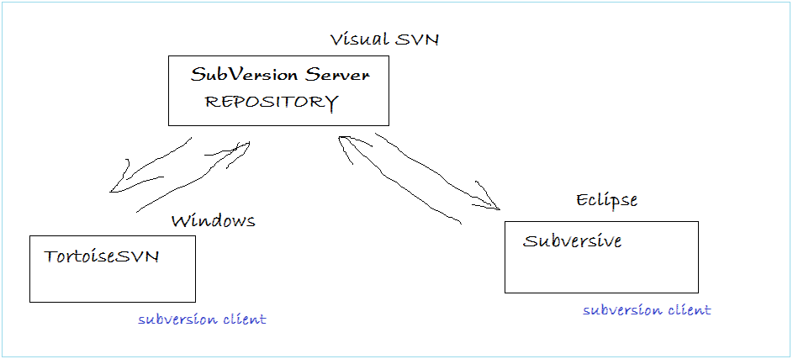

Objectives of the document:

* Instruct to download Visual SVN
* Install SVN
* Create working User, create Repository
* Decentralize Users' authority to access to Repository.

**2- Download VisualSVN**

Goto URL:

* <http://www.visualsvn.com/server/>

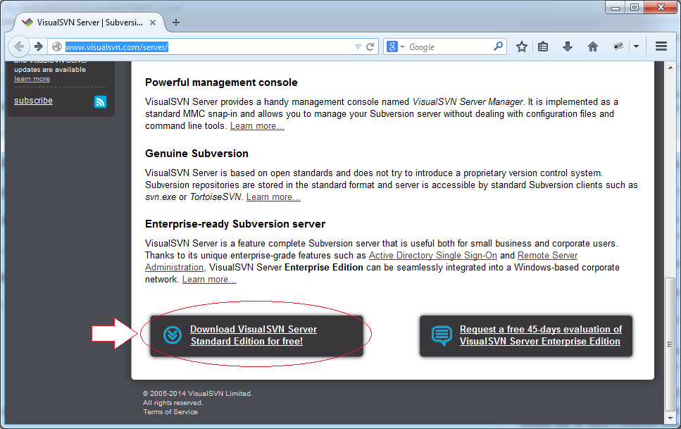

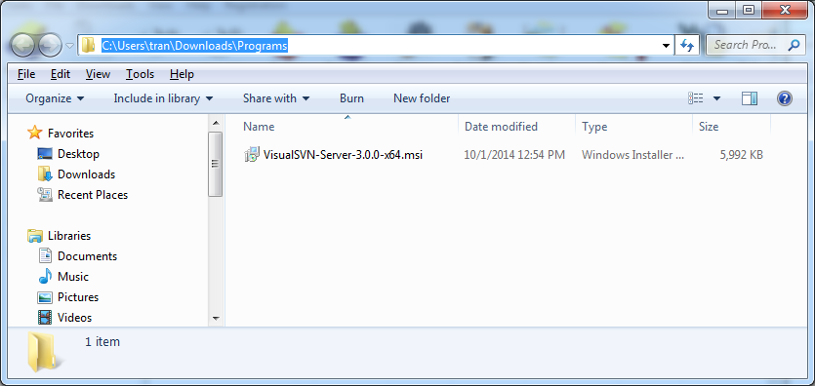

**3- Install Visual SVN**

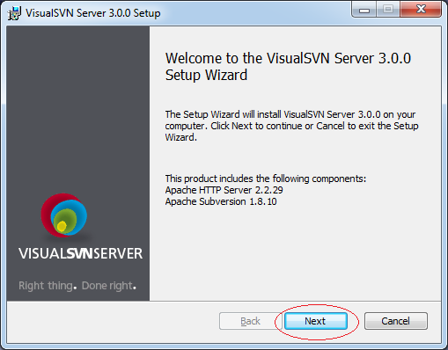

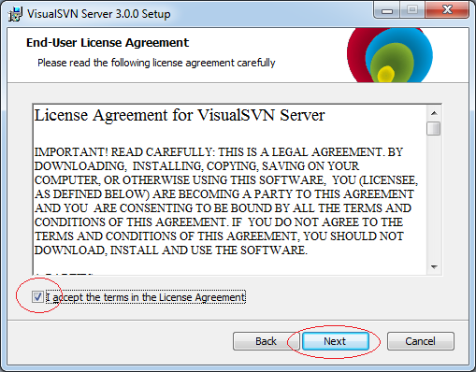

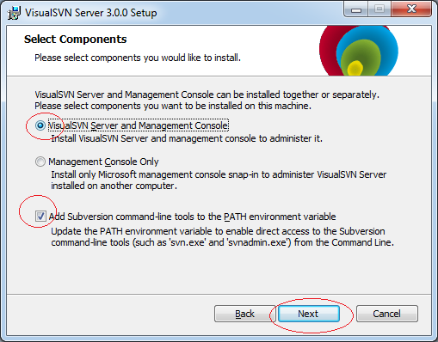

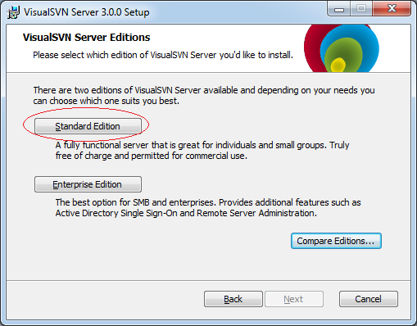

Install in a position on hardware, for example:

* C:\Program Files\VisualSVN Server

Select the position for the folder containing data (Usually you should put into a safe hardware):

* C:\Repositories

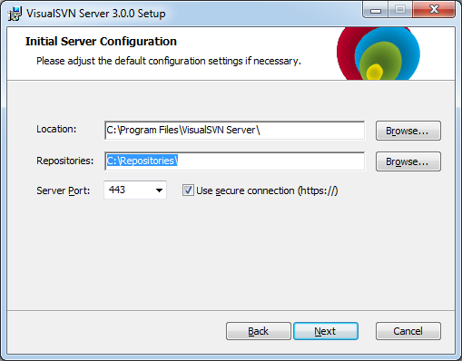

Click Finish to complete.

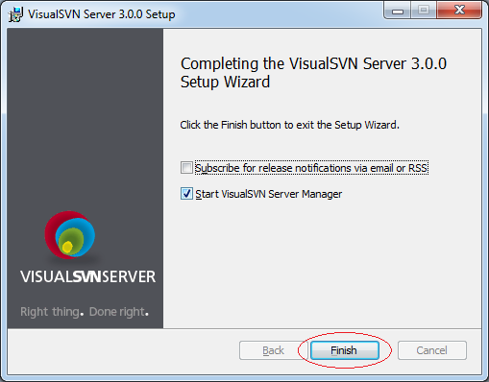

**4- Create and manage Repository**

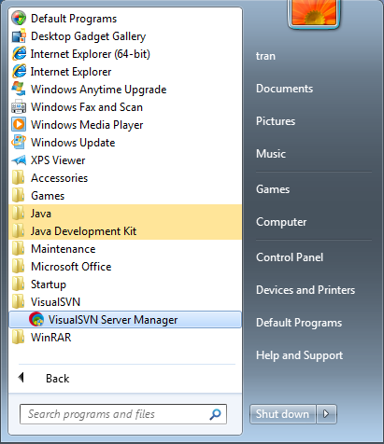

This is the image showing Visual SVN after it has been ran. We create a new user.

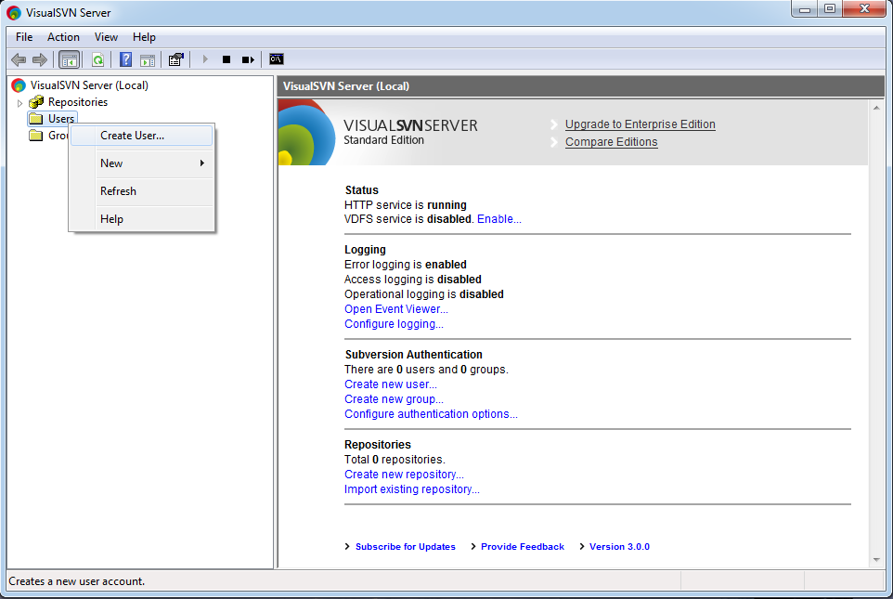

Enter username/password

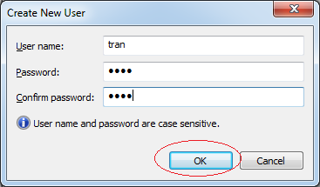

Next, we create a new **Repository** named JavaProjects. This is an empty  **Repository** without data. Data will be pushed on server from a  **subversion client** (a member of programming group), and will be taken by other members. Members can modify data and push on  **Repository.**

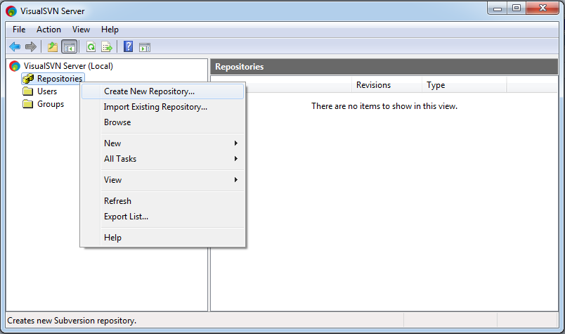

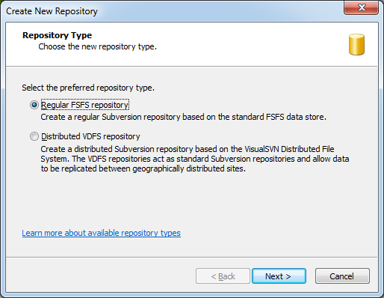

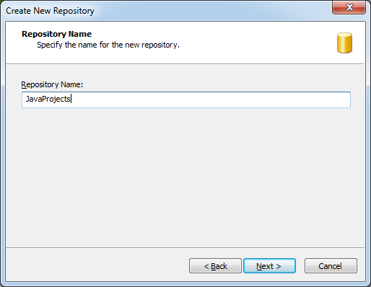

By default no one is allowed to access to this Repository, we will decentralize the authority later.

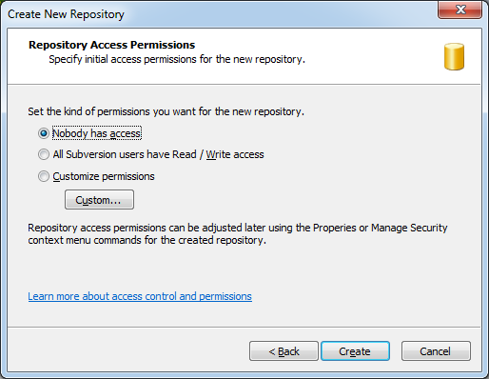

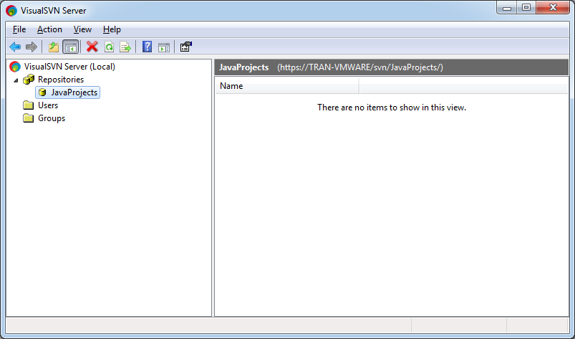

Right-click on Repository **"JavaProjects"** and select Properties

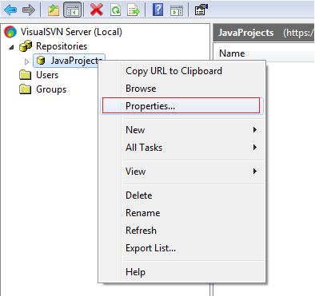

Click Add to add user who has the authority to access to this **Repository**.

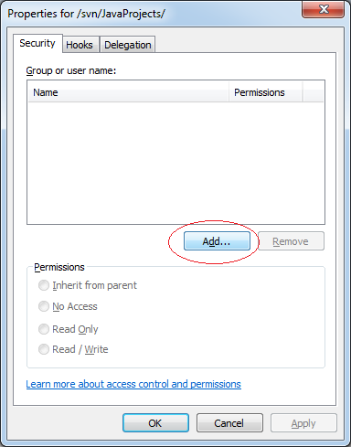

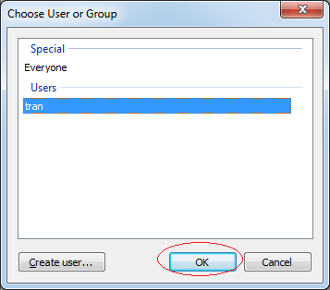

Select User's authority.

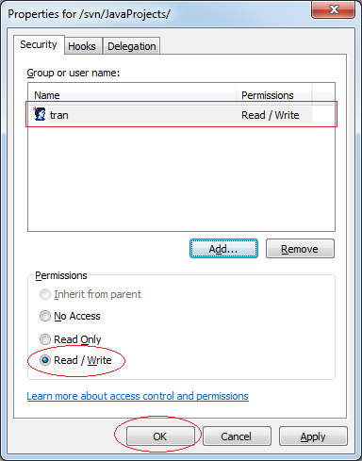

Similarly, you can create other **Repository**: **WorkingDatas**

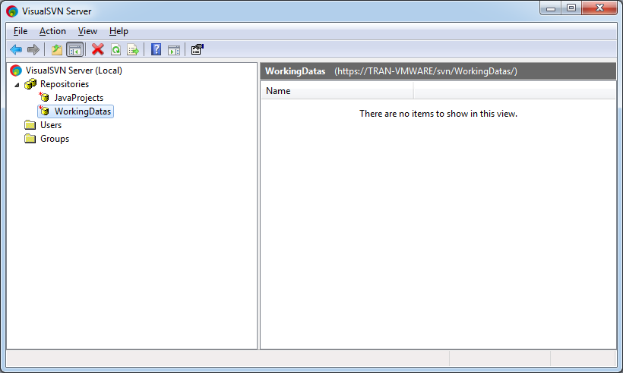

The **Visual SVN** Installation was successful.

**5- Java Programming for team using Eclipse and SVN**

You can see more guidelines: Java Programming for team using **Eclipse** and **SVN**:

* <http://o7planning.org/en/10253/java-programming-for-team-using-eclipse-and-svn>

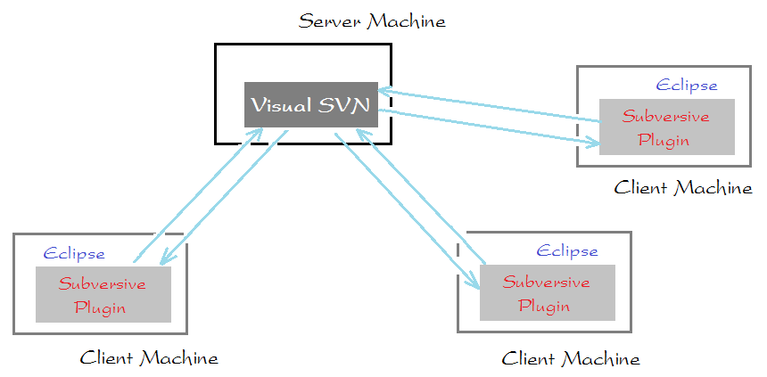

**6- Guide for installing and using Tortoise SVN**

When the groups work together through sharing files and manipulate on  **Window Explorer**, you can install   **Tortoise SVN**. See the instruction at:

* <http://o7planning.org/en/10261/installing-and-using-tortoise-svn>

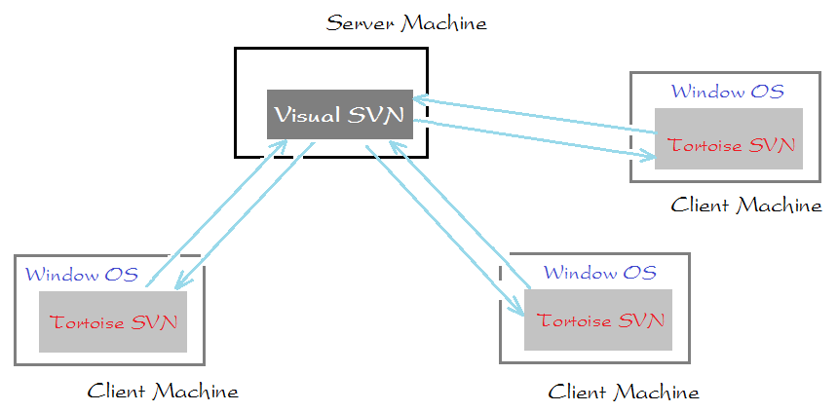

s